**PRACTICAL 3**

**Database Management Systems**

|  |  |
| --- | --- |
| **NAME: VARUN KHADAYATE** | **ROLL NO: A016** |
| **PROGRAM: BTECH SY** | **DIVISION: CSBS** |
| **BATCH: 1** | **DATE OF EXPERIMENT: 08/02/2020** |

# AIM

To understand the concept of implementing Data Manipulation Language(DML) statements.

# THEORY

## 1] INSERT

The INSERT into statement is part of the Data Manipulation Language commands. It is used to insert a new row in a table. There are two ways of using INSERT statement for inserting rows:

### i) Only values:

The first method is to specify only the value of the data to be inserted without the column names.

#### Syntax:

INSERT INTO table_name VALUES (value1, value2, value3,...,value n);

#### a) Description:

table_name : name of the table.

value1,value2,.., value n. : value of first column, second column,...column n.

#### Example:

INSERT INTO employee VALUES(1,’vivek’,40000);

### ii) Selected Column Insert:

In the second method, we will specify both the columns which we want to fill and their corresponding values as shown below:

#### Syntax:

INSERT INTO table_name (column1, column2, column3,..,column n) VALUES ( value1, value2, value3,..,value n);

#### a) Description:

table_name : name of the table.

column1,column2,... : name of first column, second column..., column n

value1,value2, value3... : value of first column, second column,...,column n

#### Example:

INSERT INTO employee(empno,ename) VALUES (1,’vivek’);

In the INSERT into <table> statement, table columns and values have a one to one relationship, (i.e. the first value described is inserted into the first column, and the second value described is inserted into the second column and so on).

Hence, in an INSERT INTO <table> statement, if there are exactly the same numbers of values as there are columns and the values are sequenced in exactly in accordance with the data type of the table columns, there is no need to indicate the column names.

However, if there are fewer values being described than there are columns in the table then it is mandatory to indicate both the table’s column name and its corresponding value in the INSERT INTO <table> sentence.

## 2] UPDATE

The UPDATE <table> statement is part of the Data Manipulation Language commands. It is used to update the data of an existing table in the database. We can update single columns as well as multiple columns using UPDATE statement as per user's requirement.

### Syntax:

UPDATE table_name SET column1 = value1, column2 = value2,... WHERE condition;

#### a) Description:

table_name : name of the table

column1 : name of first, second, thirdcolumn....

value1 : new value for first, second, thirdcolumn....

condition : condition to select the rows for which the values of columns needs to be updated.

In the above syntax, the SET statement is used to set new values to the particular column and the WHERE clause is used to select the rows for which the columns are needed to be updated. If we have not used the WHERE clause, then the columns in all the rows will be updated. Hence, the WHERE clause is used to filter particular rows.

### i) Updating all rows

The UPDATE statement updates columns in the existing table’s rows with new values. The SET clause indicates which column data should be modified and new values that they should hold. Here we omitted where clause so all table rows are updated.

Example: UPDATE employee SET salary = 4000;

### ii) Updating records conditionally

The UPDATE statement updates columns in the existing table’s rows with new values based on the WHERE condition. The SET clause indicates which column data should be modified and WHERE clause indicates which row in table will satisfy the condition and update row(s) with the new value.

UPDATE employee SET salary = 4000 WHERE empno = 21;

Hence, in the above example empno 21, salary will be updated to 4000.

## 3] DELETE

The DELETE Statement in SQL is used to delete existing records from a table. We can delete a single record or multiple records depending on the condition we specify in the WHERE clause.

### Syntax:

DELETE FROM table_name WHERE some_condition;

#### a) Description:

table_name : Name of the table

some_condition : Condition to delete particular record

We can delete single as well as multiple records depending on the condition we provide in WHERE clause. If we omit the WHERE clause then all the records will be deleted and the table will be empty.

#### Example 1 :

DELETE FROM emp;

In the above statement, if we do not apply where clause then all the records of the Employee table will be deleted.

#### Example 2 :

DELETE FROM emp where Salary<10000;

In above statement only those records are deleted were salary is less than 10000. So where clause plays big role in deleting records from the database.

# CODE SNAPS

## INSERT

### Only values

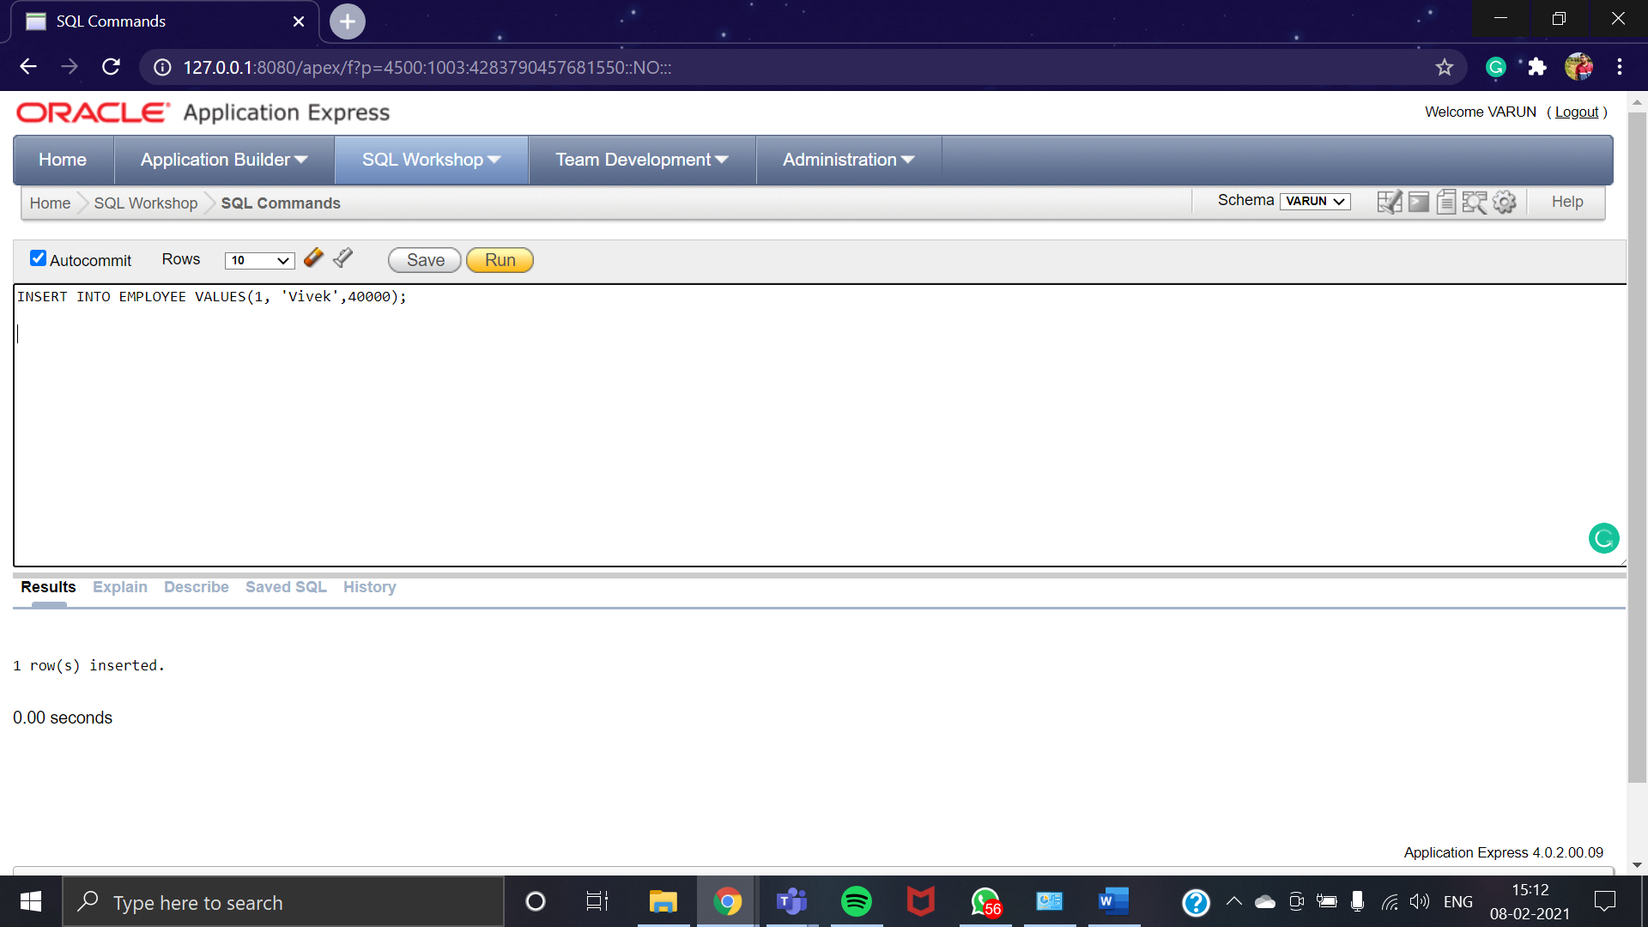

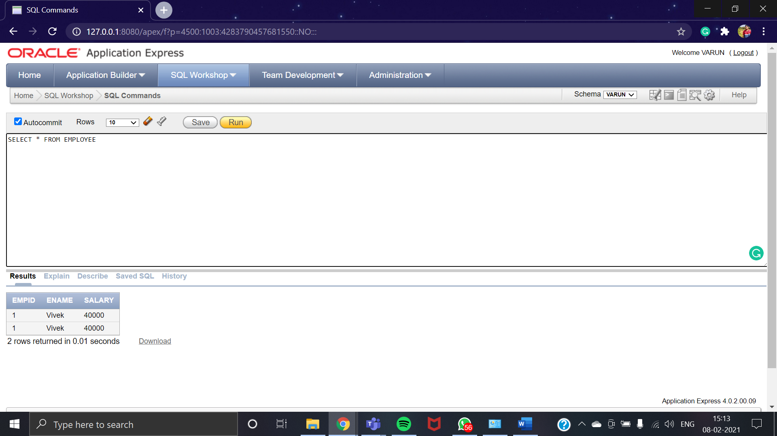

### Selected Column Insert

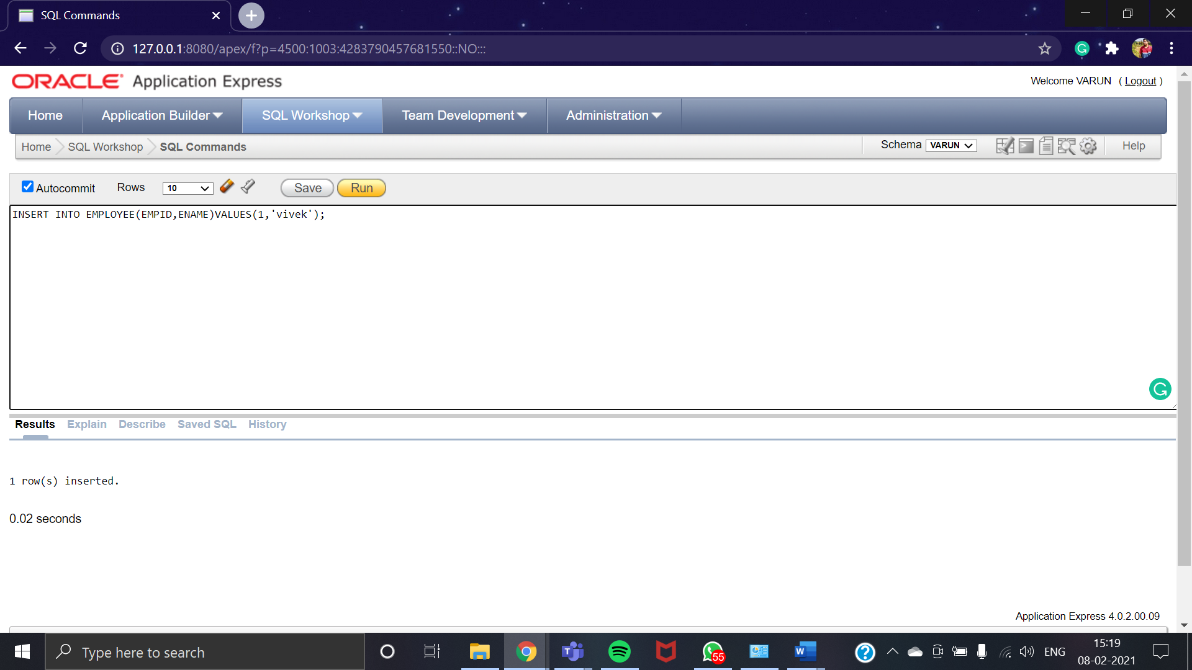

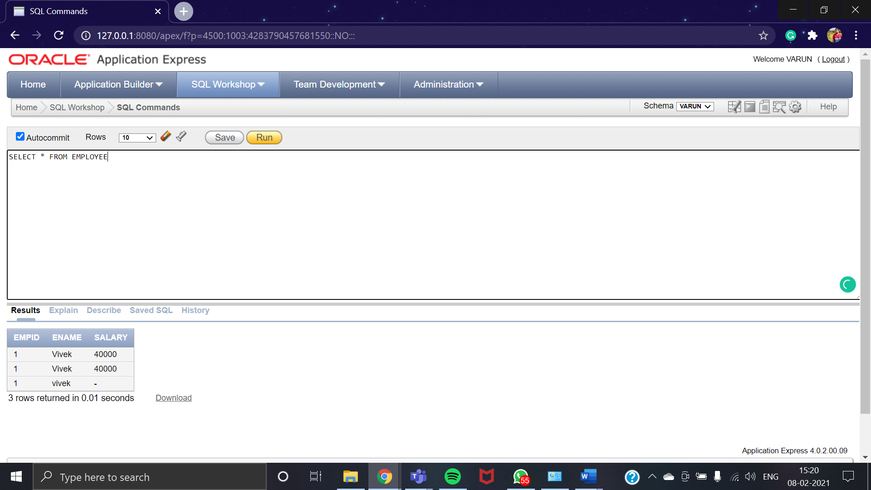

## UPDATE

### Updating all rows

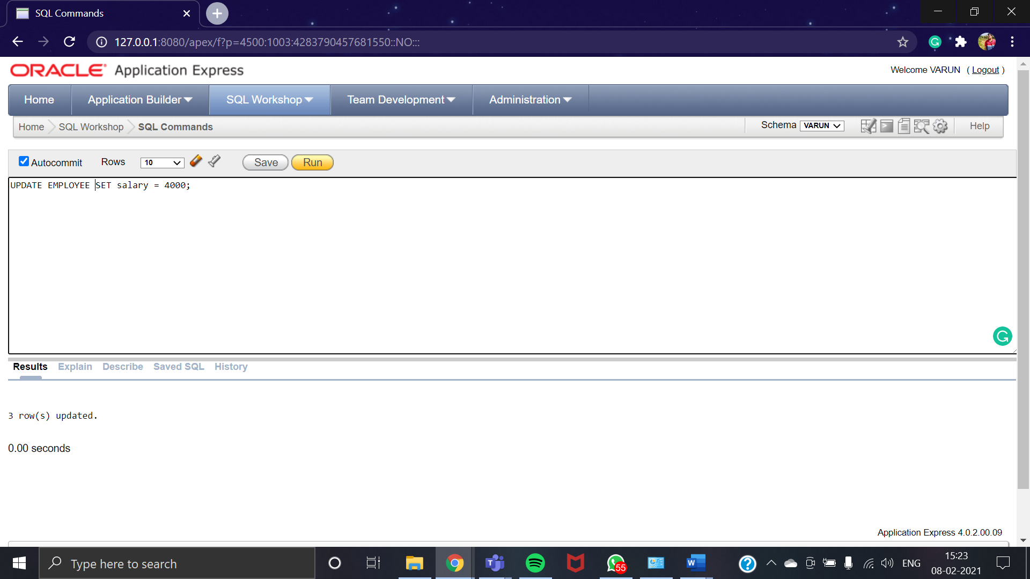

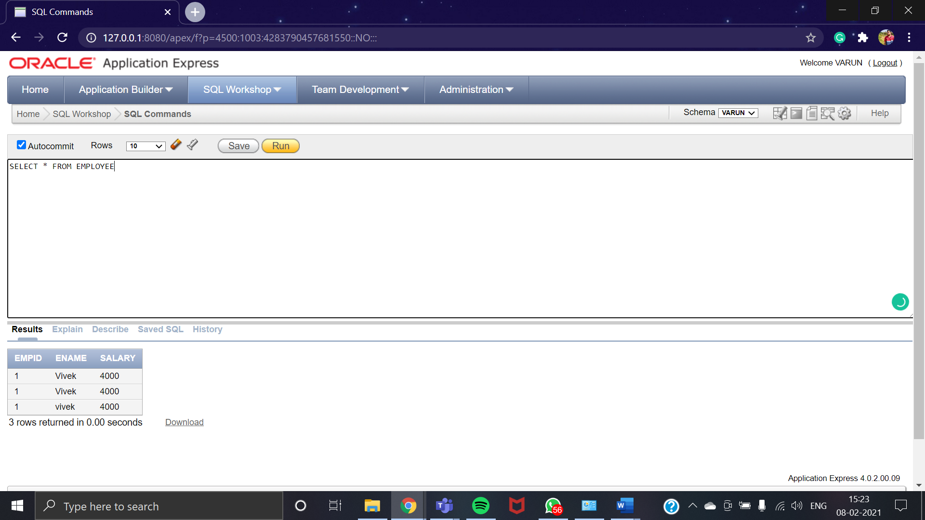

### Updating records conditionally

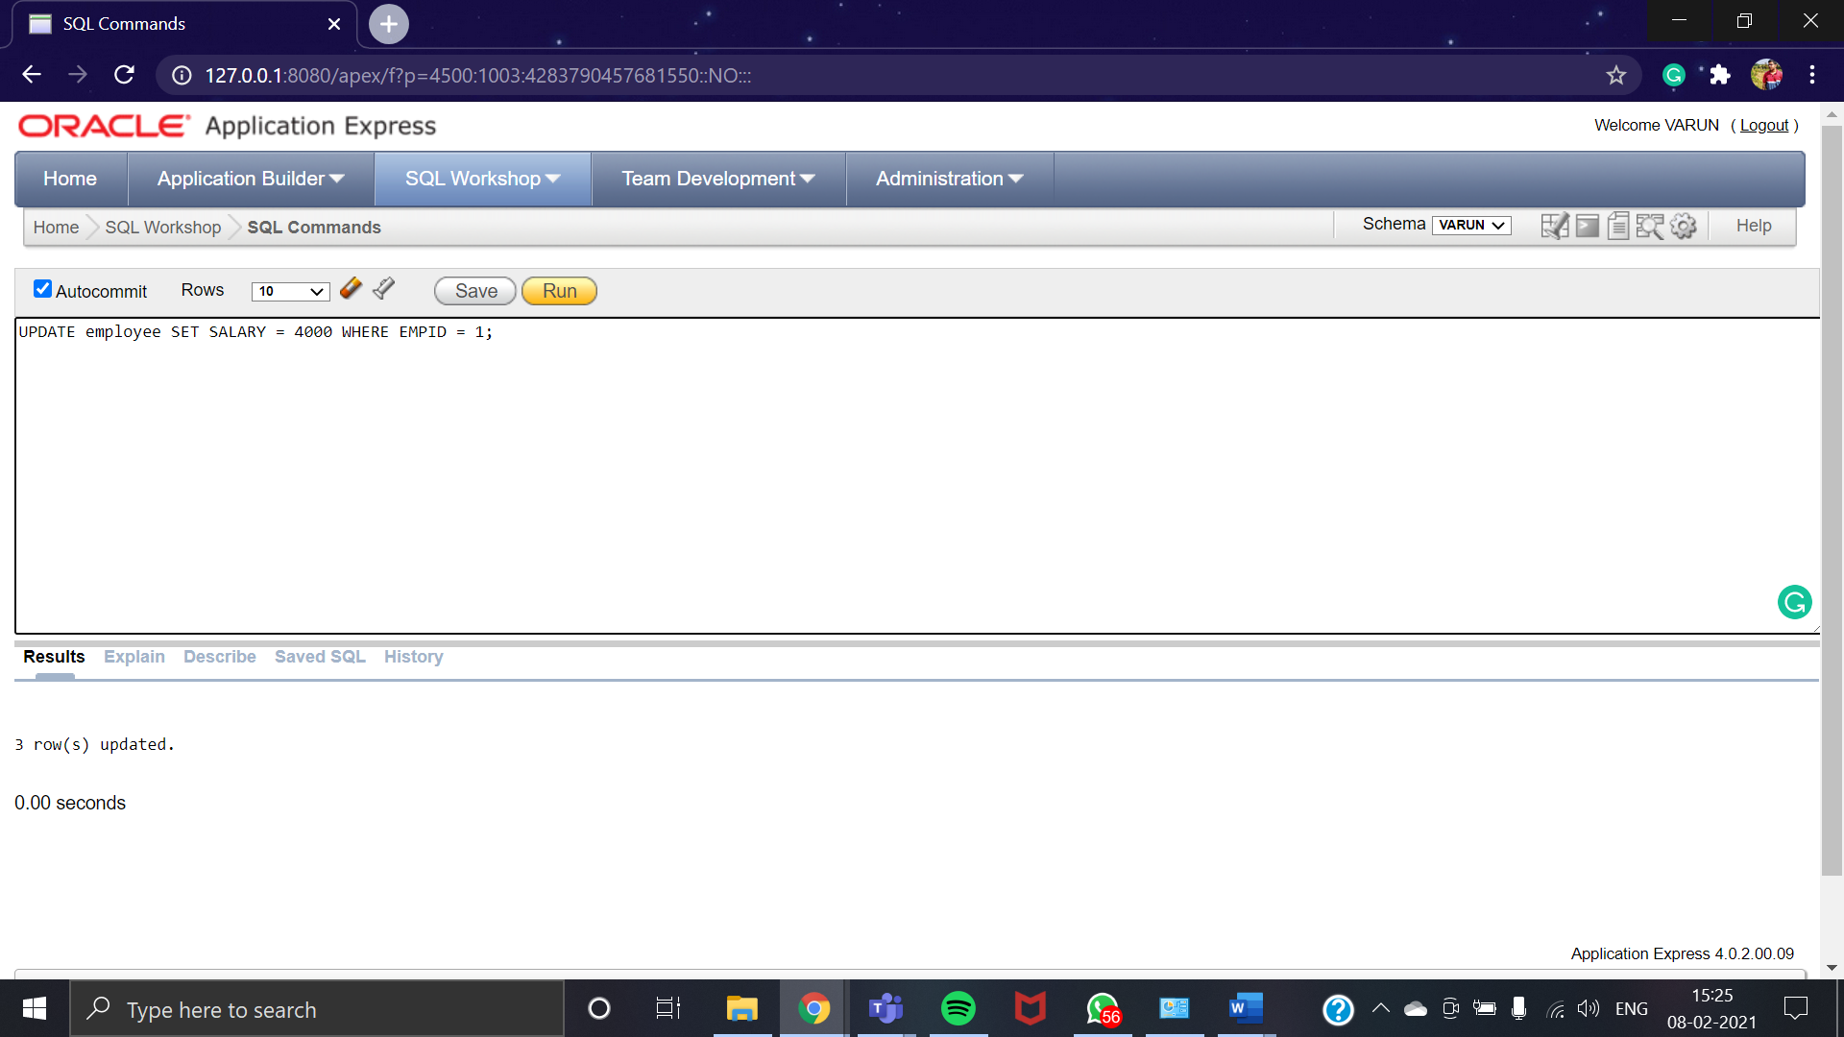

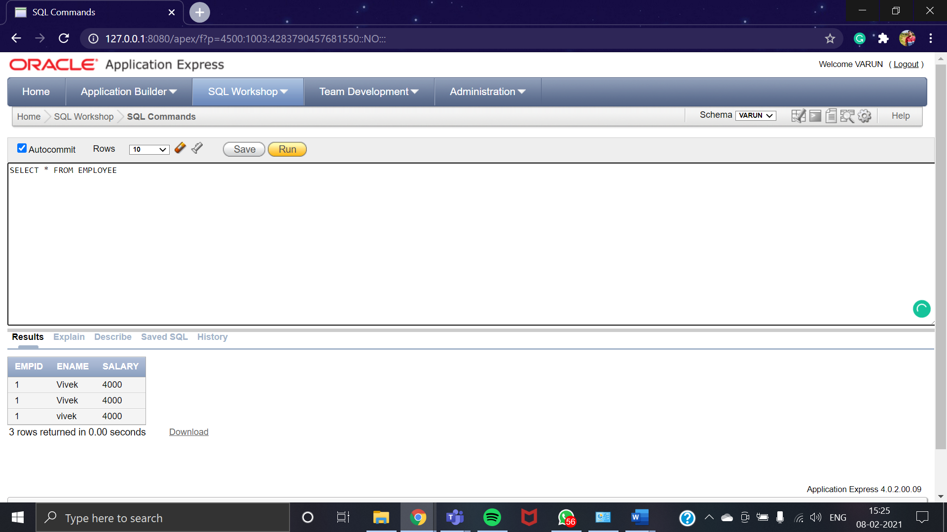

## DELETE

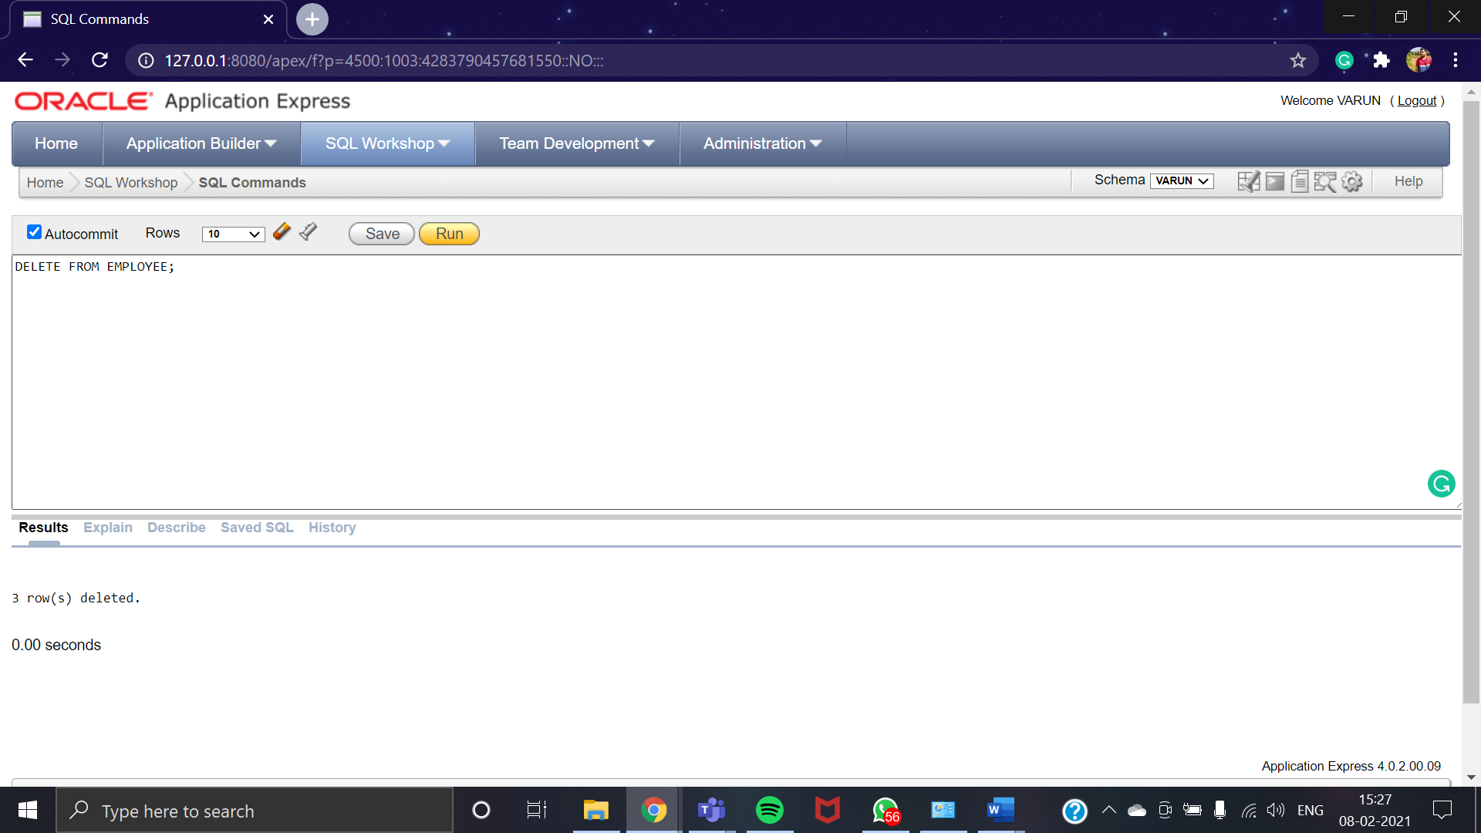

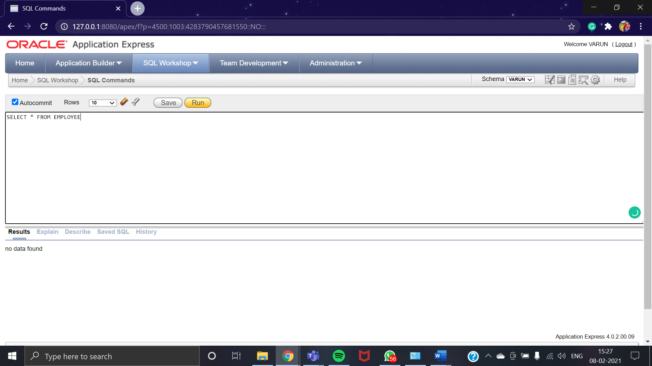

# CONCLUSION

At the end of this practical we were able to understand the various aspects of Data manipulation language commands like:

1. Inserting Data into the table, (inserting all attributes in a table or inserting selected attributes in a table).
2. Updating Data into the table (updating all tuples in a table or updating selected tuples in a table).
3. Deleting Data from the table (deleting all tuples from the table (not advisable) or deleting selected tuples from the table).